Define the following concepts using screenshots and text:

1. Repository

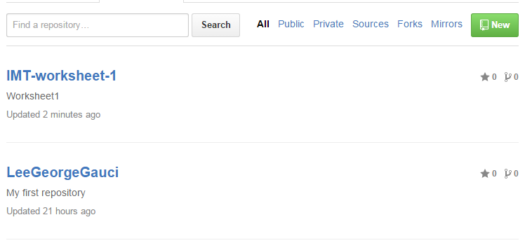

A repository is a directory where storage space is allocated, this allocates space contains all the project files; it also stores each files revision history and can be published both private and public.

1. Commit

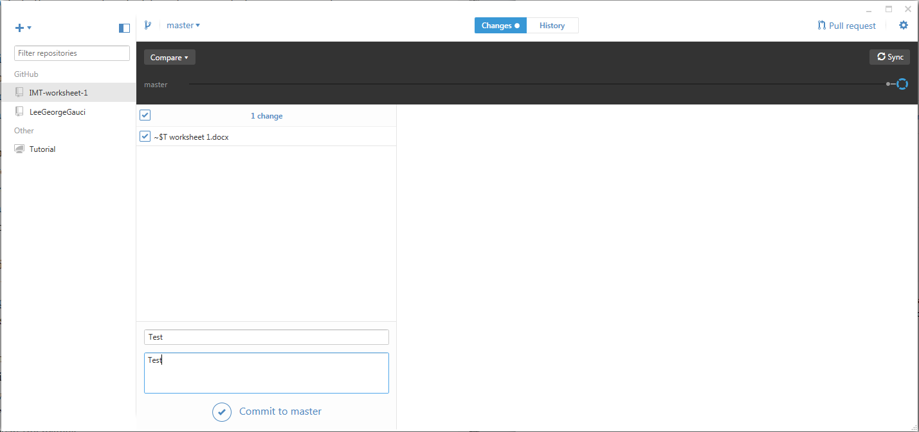

The commit function takes a “screenshot of” each step of your work in the given repository. This allows the user to restore or reevaluate previous versions of your work.

1. Commit description

If one or more users are editing the same file, Commit description allows users to add detailed information regarding the changes done by that specific user. This helps organize work and reduce confusion.

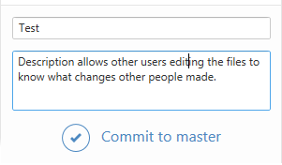

1. Github desktop

Github desktop is a UI which allows user to manage their content by adding, creating or cloning repositories onto their personal pc. It also shows the changes done, commits them and syncs them to your online account.

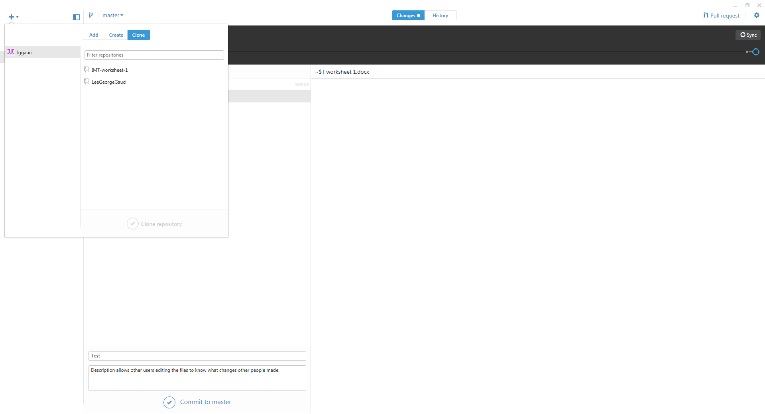

1. Git Sync

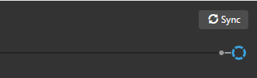

When editing files, everything is still done locally I.E your pc. Git Sync allows the user to upload the contents of the repository to the internet which can later be viewed and downloaded.

1. What ‘download zip’ does.

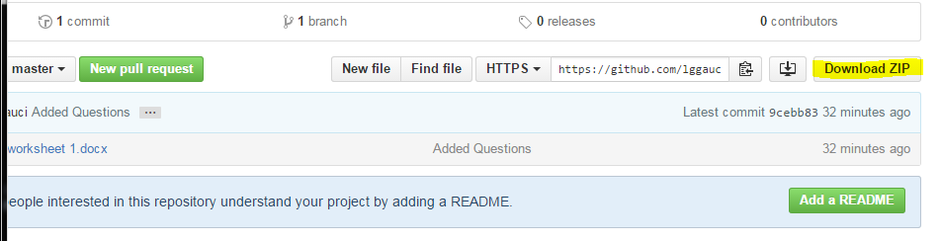

Downloads a zip file containing the selected repository which in turn can be edited pm your pc.